Topic 6.6: Sum of Subarray Minimums
Question
Given an array of integers arr, find the sum of min(b), where b ranges over every contiguous subarray of arr. Since the answer may be large, return the answer modulo 10⁹ + 7.
Aim
To calculate the sum of minimum values of all contiguous subarrays of the given array using an efficient algorithm.
Algorithm
- For each element in the array, determine how many subarrays consider this element as the minimum.
- Use monotonic stacks to compute:
  - The distance to the previous smaller element.
  - The distance to the next smaller element.
- The contribution of each element is calculated as:
- arr[i] * left[i] * right[i]
where left[i] is the number of subarrays ending at i in which arr[i] is the minimum, and right[i] is the number of subarrays starting at i in which arr[i] is the minimum.
- Sum all contributions and take modulo 10⁹ + 7.
Output
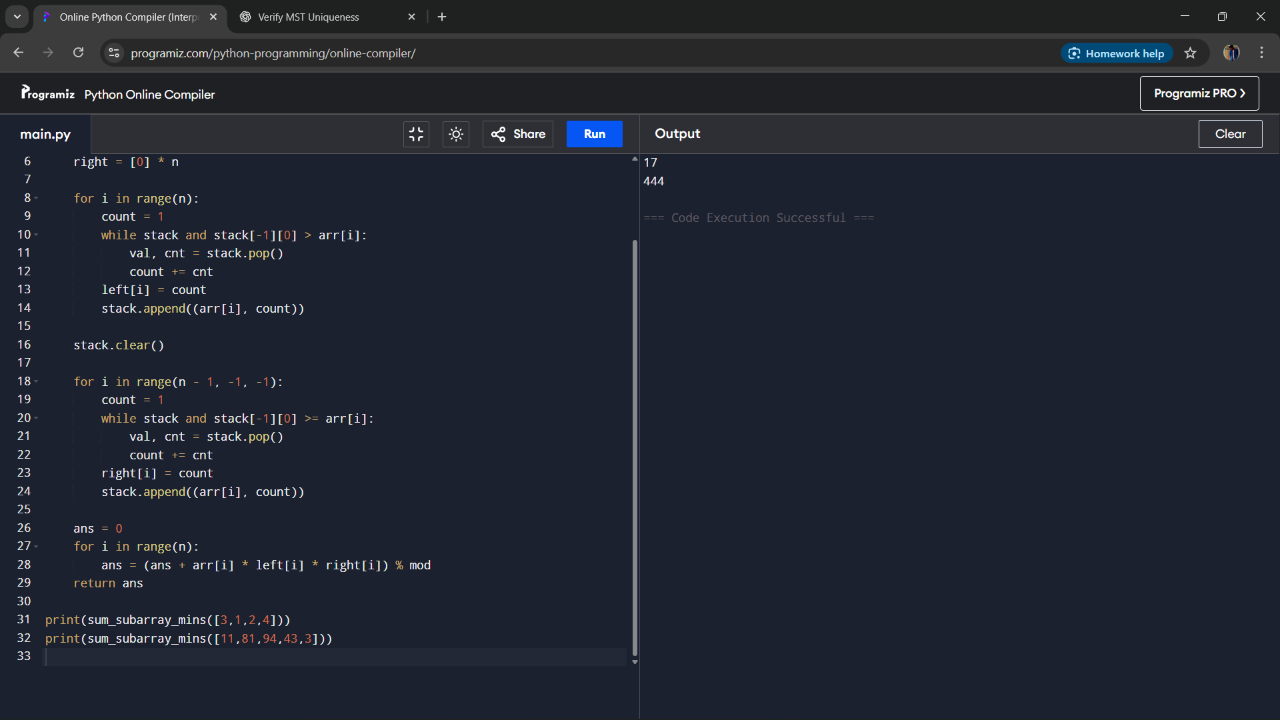
Result
The program computes the sum of subarray minimums efficiently using monotonic stack logic.
Performance Analysis
- Time Complexity: O(n), as each element is pushed and popped from the stack once.
- Space Complexity: O(n) for storing stack and contribution arrays.

